ORDER OF STARTS – ROLEX FASTNET RACE 2025
As @8 July
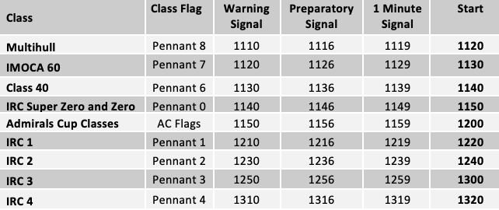
NB: Subject to change

